CSE230: Discrete Mathematics | Practice Sheet 4: Set Theory
Note: This practice sheet contains a collection of questions from Rosenn’s textbook, past test questions, other books, online sources and some new variations. But this does NOT serve as a definitive / exhaustive sample template of all problems.
No official solutions will be provided to these questions. The problemsets serve as a tool to encourage active, engaging discussion and more open communication. You should try to solve these yourself, then reach out to any faculty or ST or your peers to verify your answers. Make mistakes, then discuss to fix those mistakes. Same goes for questions you may find yourself stuck on.

Q1 | Determine whether each of these pairs of sets are equal.  a) {1, 3, 3, 3, 5, 5, 5, 5, 5}, {5, 3, 1}  b) {{1}}, {1, {1}}  c) ∅, {∅}
Q2 | How many elements does each of these sets have where a and b are distinct elements? Here P represents the power set.  a) P({a, b, {a, b}})  b) P({∅, a, {a}, {{a}}})  c) P(P(∅))
Q3 | List all the subsets of:  a){1,2,3}  b) {ϕ,λ,Δ,μ}  c) {∅}
Q4 | What is the cardinality of each of these sets?  a) {a}  b) {{a}}  c) ∅  d) {∅}  e) {∅,{∅}}  f) {∅,{∅},{∅,{∅}}}
Q5 | Find the power set of each of these sets, where p and q are distinct elements.  a) {q}  b) {p, q}  c) {∅,{∅}}
Q6 | Find if the following statements are True or False.  a) 7∈{6,7,8,9}  b) 5∉{6,7,8,9}  c) {2}⊈{1,2}  d) ∅⊈{α,β,x}  e) ∅={∅}
Q7 | Let A={1, 5, 31, 56, 101}, B={22, 56, 5, 103, 87}, C={41, 13, 7, 101, 48} and D={1,3,5,7...}  Give the sets resulting from:  a) A∩B  b) C∪A  c) C∩D  d) (A∪B)∪(C∪D)
Q8 | Assume that the universal set is the set of all integers.  Let,  A={−7,−5,−3,−1,1,3,5,7}  B={x∈Z|x²<9}  C={2,3,4,5,6}  D={x∈Z|x≤9}  In each of the following fill in the blank with most appropriate symbol from ∈,∉,⊂,=,≠,⊆ , so that resulting statement is true.  - A____D  - 3____B  - 9____D  - {2}____ C^{c}  - ∅____D  - A____C  - B____C  - C____D  - 0____A∩D  - 0____A∪D
Q9 | Let A={r,e,a,s,o,n,i,g},B={m,a,t,h,e,t,i,c,l} and C = the set of vowels. Calculate:  a) A∪B∪C.  b) A∩B.  c) C^{c}.
Q10 | Given sets A and B in a universe U, draw the Venn diagrams of each of these sets.  a) A → B = {x ∈ U | x ∈ A → x ∈ B}  b) A ↔ B = {x ∈ U | x ∈ A ↔ x ∈ B}
Q11 | Find A³ if :  a) A = {0}.  b) A = {0, a}
Q12 | Let A = {a, b, c}, B = {x, y}, and C = {0, 1}. Find  a) A × B × C.  b) C × B × A.  c) C × A × B.  d) B × B × B.
Q13 | Given sets A = {1, 2, 3} and B = {x, {y}}, find A×B and B×A. Are the sets equal?  What is the cardinality of the cartesian product B×A?
Q14 | Use a Venn diagram to illustrate the relationship A ⊆ B and B ⊆ C.
Q15 | Use a Venn diagram to illustrate the relationships A ⊂ B and B ⊂ C.
Q16 | Suppose that A, B, and C are sets such that A ⊆ B and B ⊆ C. Show that A ⊆ C.
Q17 | Let A = {1, 2, 3, 4, 5} and B = {0, 3, 6}. Find  a) A ∪ B.  b) A ∩ B.  c) A − B.  d) B − A.
Q18 | Let A = {a, b, c, d, e} and B = {a, b, c, d, e, f, g, h}. Find  a) A ∪ B.  b) A ∩ B.  c) A − B.  d) B − A.
Q19 | Prove the second De Morgan law that if A and B are sets, then (A ∪ B)^{c} = A^{c} ∩ B^{c} by  a) showing each side is a subset of the other side.  b) using a membership table.
Q20 | Use a membership table to show that A ∩ (B ∪ C) = (A ∩ B) ∪ (A ∩ C).
Q21 | Using set identities, show that (A ∪ (B ∩ C))^{c} = (C^{c} ∪ B^{c}) ∩ A^{c}
Q22 | Prove the complement laws using membership table:  a) A ∪ A^{c} = U.  b) A ∩ A^{c} = ∅.
Q23 | Let A and B be two finite sets such that n(A) = 20, n(B) = 28 and n(A ∪ B) = 36,  find n(A ∩ B) where n(S) representing the number of elements in the set S.
Q24 | Let A, B, and C be sets. Show that  a) (A ∪ B) ⊆ (A ∪ B ∪ C).  b) (A ∩ B ∩ C) ⊆ (A ∩ B).  c) (A − B) − C ⊆ A − C.
Q25 | In a group of 200 students, 85 students are attending leadership training programs, 50 students are involved in a team-building workshop . There are 15 students who are both attending leadership training programs and participating in the team-building workshop. Determine the number of students who are involved in exactly one of the activities.
Q26 | 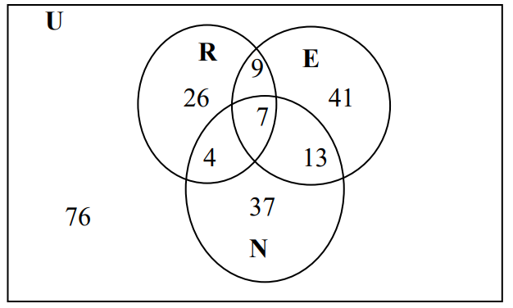  Use the diagram above to find the cardinality for each problem.  1. n(N)  2. n[(R ∩ E) ∪ N]  3. n(E′)  4. n(E\R)  5. n(U)  6. n(R ∪ E ∪ N)
Q27 | Illustrate each of the following by shading the Venn diagrams below.  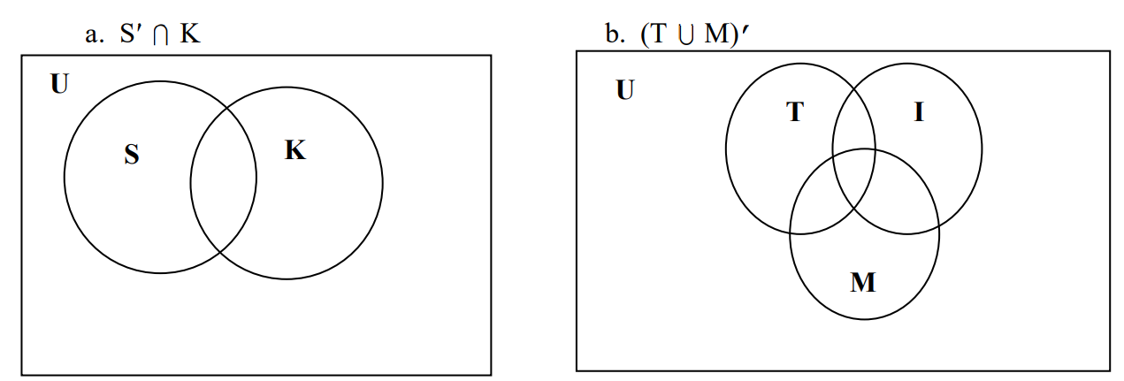
Q28 | Use the Venn diagram to work the following problem in three steps A′ ∪(B ∩C).  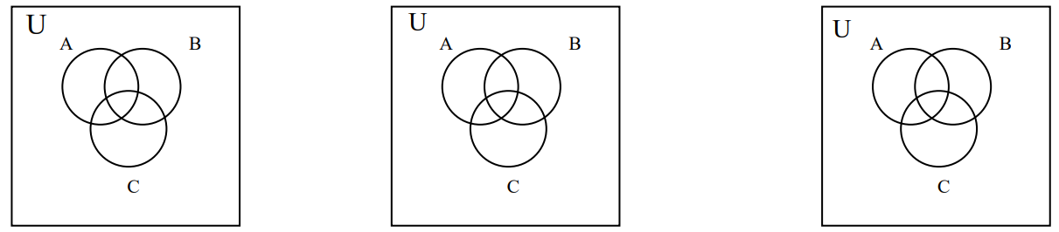
Q29 | A teacher surveyed her class of 43 students to find out how they prepared for their last test. She found that 24 students made flash cards, 14 studied their notes, and 27 completed the review assignment. Of the entire class of 43 students, 12 completed the review and made flash cards, 9 completed the review and studied their notes, and 7 made flash cards and studied their notes, while only 5 students completed all three of these tasks. The remaining students did not do any of these tasks. Represent this information in a Venn Diagram.
Q30 | A number of deer were surveyed about activities that they enjoy. The results are summarized in the Venn diagram below:  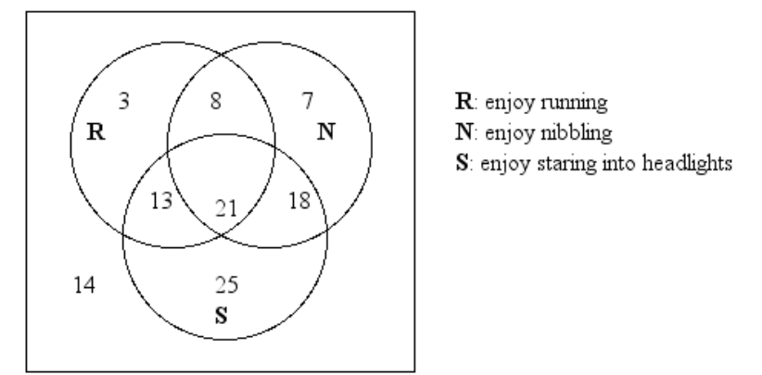  How many deer :  - Enjoy running or staring into headlights?  - Enjoy nibbling and running?  - Enjoy exactly one of these activities?  - Enjoy staring into headlights but not running?  - Enjoy nibbling?  - Don't enjoy any of the activities?  - Enjoy any two activities only?
Q31 | Draw a Venn diagram using 3 sets Q, T and P. None of these 3 sets are pairwise disjoint. Moreover, $P∩Q∩T≠ϕ$. How many disjoint regions are there? Indicate which regions fall under $(T∩Q)^{c}-P$.
Q32 | A survey of 1,200 people was conducted on three types of sports they enjoy: soccer, basketball, and baseball. Out of these, 670 enjoy soccer, 510 enjoy basketball, and 760 enjoy baseball. It was found that 320 people enjoy all three sports, while 45 people do not enjoy any of the three sports.  - How many people enjoy exactly two of these sports?  - How many people enjoy at least two of these sports?  - How many people enjoy exactly one of these sports?
Q33 | A company surveyed 300 users about their use of WhatsApp, Instagram, and Telegram.  Out of these, 180 users reported using WhatsApp, 160 users reported using Instagram,  and 150 users reported using Telegram. A total of 90 users reported using both  WhatsApp and Instagram, 75 users reported using both WhatsApp and Telegram, and 70  users reported using both Instagram and Telegram. Exactly 22 users reported that they do  not use any of the three platforms.  - How many users use at least one platform?  - How many users use exactly one platform?  - How many users use Instagram or Telegram but not WhatsApp?  - How many users use Instagram and Telegram but not WhatsApp?  - How many users use at least two platforms?  - What is the ratio of students using exactly only one platform in proportion to using exactly only two platforms?  - How many users use WhatsApp but not Telegram ?
Q34 | Let A = { x ∈ N | x is even and 2x²+3x < 100 }, B = { x ∈ Z | |x| ∈ {0, 2} } and the universal set, U = A ∪ B.  - Compute the sets A and B.  - Find the following sets: (A ∪ B), (A – B), (A – B)^{c} and (B – A).  - Determine the set P(B) – P(B – A).
Q35 | Consider the following sets:  U = {x : x ∈ N and x is odd}  A = {x ∈ N : 2 ≤ x ≤ 7}  B= {x ∈ N : 3 < x < 6}  C = {x ∈ N : x² > 5 and x³ < 130}  Now answer the following questions.  - Determine A^{c} and (C-B).  - Calculate B × C and P(A ∩ C).  - Show whether C is a subset of A. Also, determine if it can be a proper subset.
Q36 | In a survey of 374 coffee drinkers, it was found that 64 take only sugar, 82 take  only cream, and 65 do not take sugar nor cream with their coffee. How many take:  - sugar and cream with their coffee?  - Cream?  - neither sugar nor cream?  - exactly one of these two additions?  - at least one of these two additions?
Q37 | Sixty-seven students were asked about which subject they enjoy most. The  survey revealed that 33 enjoy Math, 45 enjoy Science, 40 enjoy English, 17 enjoy Science  and English only, 16 enjoy both Math and Science, 14 enjoy all three subjects, and 25 enjoy  exactly two of the three subjects.  - How many students surveyed enjoy Math and English?  - How many students surveyed enjoy Science or English but not Math?  - How many students surveyed enjoy at most one of the three subjects mentioned?
Q38 | Consider the following sets:  U = {x ∈ Z : –8 ≤ x ≤ 8}  A = {x ∈ U : x is even and x² < 50}  B = {x ∈ U : x is multiple of 2 but not a multiple of 4}  C = {x ∈ U : 0 < x² – 4 < 30}  - Is the empty set (∅) a subset of every set? Is it also a proper subset of every set?  - Compute the sets A, B and C. Also find the sets: (A ∩ B) and A ∪ (B ∩ C)  - Find the following sets: (B – A)^{c} and {m, n} × (A ∩ B).
Q39 | A survey of 280 participants was conducted to find out which languages they do not speak among Bangla, English, and Arabic. The results showed that:  - 120 people do not speak Bangla.  - 165 people do not speak English.  - 190 people do not speak Arabic.  - 20 people do not speak any of the three languages.  - 65 people speak exactly two languages.  - How many people speak at least one language?  - How many people speak exactly one language?  - How many people speak all three languages?
Q40 | Consider the following sets:  A = {x : x ∈ Z, –10 ≤ x ≤ 10 and 40 < x² < 50}  B = {x : x is the fourth prime number}  C = {x : x ∈ Z, x is multiple of 5 and |x| ≤ 15}  - Find P(B) and P(A), and shortly explain whether P(B) ⊂ P(A) is true or not..  - Generate (A×B) – C and check whether it’s equal to (B×A) – C..  - If universal set, U = A ∪ B ∪ C, then compute the elements of the set: B^{c}∩ A.  - Calculate |P(A)| – |P(C)|. Here, P(A) denotes the power set of A and |A| denotes the cardinality of A.

